
GO-STANDARD NURSERY & PRI-SCHOOL
END OF YEAR EXAMINATION 2023
MIDDLE CLASS: (4 – 5 YEARS)
LEARNING AREA 5: LANGUAGE DEVELOPMENT II

My name is: …………………………………..………………………….
My School is: ……………………………..………….…………………..
I am in: ………………………………..………………………………………………..

- Match a word to a word.

box bell

bell toy

tin box

toy pen

pen tin
- Copy and read.
basin _________________________

bag ___________________________

bell ___________________________

book __________________________

coat ___________________________

- Read and draw
box bag ball

man book

- Match a sound to a picture.
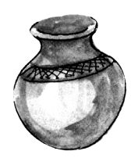
s



e



t


c



p

- Draw a picture for a sound given.

c

t

p

d

s

“Good Luck”

